CHAPTER ONE

ANTENNA PARAMETERS

  - Overview

Antenna is a metallic structure designed for radiating and receiving electromagnetic energy. It acts as a transitional structure between the guiding device (e.g. waveguide, transmission line) and the free space. There are several critical parameters that affect an antennas performance and can be adjusted during the design process. These are impedance, gain, aperture or radiation pattern, polarization, efficiency and bandwidth.
In this chapter the principles and characteristics of antennas and its performance parameters are examined.

1.2 Electromagnetic Radiation

Electromagnetic radiation includes radio waves, microwaves, infrared radiation, visible light, ultraviolet waves, X-rays, and gamma rays. Together they make up the electromagnetic spectrum. They all move at the speed of light$c=$$3×{\text{10}}^{8}m/s$. The only difference between them is their wavelength $λ$$(m)$ (the distance a wave travels during one complete cycle [vibration]), which is also directly related to the amount of energy the waves carry.
The shorter the wavelength, the higher the energy. Figure 1.1 lists the electromagnetic spectrum components according to wavelength and frequency $f(\text{Hz})$ (the number of complete cycles per second) [2].
Radio waves are very long compared to the rest of the electromagnetic spectrum. The radio spectrum is divided up into a number of bands based on their wavelength and usability for communication purposes. They extend from the Very Low Frequency $\text{VLF}$ portion of the spectrum through the Low$(\text{LF})$, Medium$(\text{MF})$, High$(\text{HF})$, Very High$(\text{VHF})$, Ultra High$(\text{UHF})$, and Super High $(\text{SHF})$ to the Extra High Frequency $(\text{EHF})$ range as depicted in the illustration below.

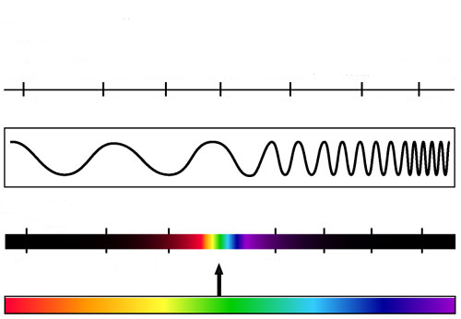
Wavelength, (m)
Radio Microwave Infrared Visible Ultraviolet X-Ray Gamma Ray
Frequency $(\text{Hz})$
${\text{10}}^{4}$ ${\text{10}}^{8}$ ${\text{10}}^{\text{12}}$
${\text{10}}^{\text{15}}$ ${\text{10}}^{\text{16}}$ ${\text{10}}^{\text{18}}$ ${\text{10}}^{\text{20}}$
${\text{10}}^{3}$ ${\text{10}}^{−2}$ ${\text{10}}^{−5}$ ${\text{10}}^{−6}$ ${\text{10}}^{−8}$ ${\text{10}}^{−\text{10}}$ ${\text{10}}^{−\text{12}}$

Figure 1.1 Electromagnetic Spectrum [2].

Above the $(\text{EHF})$ band comes infrared radiation and then visible light [2]. Table 1.1 below, presents the electromagnetic spectrum and applications.

Table 1.1 Electromagnetic Spectrum and Some Applications [2].

Band | Frequency | Wavelength | Applications
VLF | 3 - 30 kHz | 100 km - 10 km | Long range navigation and marine radio
LF | 30 - 300 kHz | 10 km - 1 km | Aeronautical and marine navigation
MF | 300 kHz - 3 MHz | 1 km - 100 m | AM radio and radio telecommunication
HF | 3 - 30 MHz | 100 m - 10 m | Amateur radio bands, NRC time signal
VHF | 30 - 300 MHz | 10 m - 1 m | TV, FM, cordless phones
HFU | 300 MHz - 3 GHz | 1 m - 10 cm | UHF TV, satellite, air traffic radar, etc
SHF | 3 - 30 GHz | 10 cm - 1 cm | Mostly satellite TV and other satellites
EHF | 30 - 300 GHz | 1 cm - 1 mm | Remote sensing and other satellites
Radio waves propagate much like surface water waves. They travel near the Earth’s surface and also radiate sky ward at various angles to the Earth’s surface. As the radio waves travel, their energy spreads over an ever-increasing surface area. A typical radio wave has two components, a crest (top portion) and a trough (bottom portion). These components travel outward from the transmitter, one after the other, at a consistent velocity. The distance between successive wave crests is called a wavelength and is commonly denoted by $λ$ as shown in Figure 1.2.
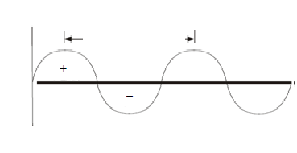
$$λ$$
Figure 1.2 Radio Wave [2].

Frequency is measured and stated in hertz ($\text{Hz})$. Frequency has an inverse relationship to the concept of wavelength; simply, frequency is inversely proportional to wavelength$λ$ [2]. The frequency $f$ is defined as:
$f=\frac{c}{λ}$. (1.1)

  - Antenna Radiation

A conducting wire radiates mainly because of time-varying current or an acceleration (or deceleration) of charge. If there is no motion of charges in a wire, no radiation takes place, since no flow of current occurs. Radiation will not occur even if charges are moving with uniform velocity along a straight wire. However, charges moving with uniform velocity along a curved or bent wire will produce radiation. If the charge is oscillating with time, then radiation occurs even along a straight wire [3].
The radiation from an antenna can be explained with the help of Figure 1.3 which shows a voltage source connected to a two conductor transmission line. When a sinusoidal voltage is applied across the transmission line, an electric field is created which is sinusoidal in nature and these results in the creation of electric lines of force which are tangential to the electric field. The magnitude of the electric field is indicated by the bunching of the electric lines of force. The free electrons on the conductors are forcibly displaced by the electric lines of force and the movement of these charges causes the flow of current which in turn leads to the creation of a magnetic field. Due to the time varying electric and magnetic fields, electromagnetic waves are created and these travel between the conductors. As these waves approach open space, free space waves are formed by connecting the open ends of the electric lines.
Since the sinusoidal source continuously creates the electric disturbance, electromagnetic waves are created continuously and these travel through the transmission line, and radiated into the free space. Inside the transmission line and the antenna, the electromagnetic waves are sustained due to the charges, but as soon as they enter the free space, they form closed loops and are radiated [3].
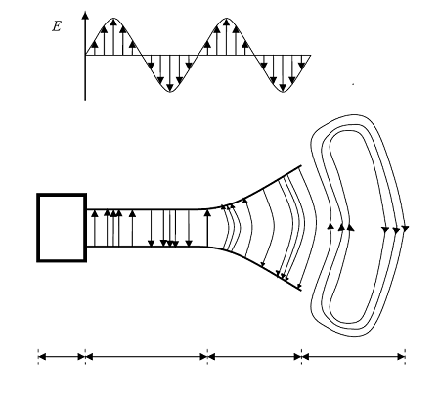
Transmission line
Source
Free Space Wave
Antenna
Figure 1.3 Radiations From an Antenna [3].

1.4 Near and Far Field Regions

The field patterns, associated with an antenna, change with distance and are associated with two types of energy: radiating energy and reactive energy. Hence, the space surrounding an antenna can be divided into three regions.

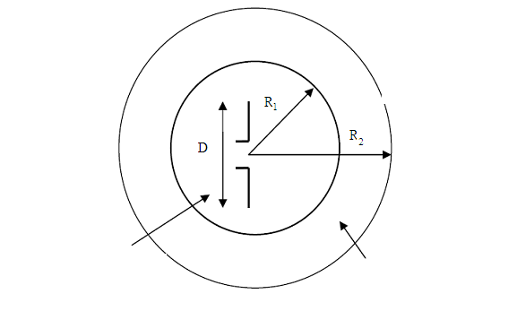
Reactive Near Field Region
Reactive Near Field Region
Far Field Region
Radiation Near Field
Region
Figure 1.4 Field Regions Around an Antenna [3].

The three regions shown in Figure 1.4 are:
• Reactive near-field region: In this region, the reactive field dominates. The reactive
energy oscillates towards and away from the antenna, thus appearing as reactance. In this region, energy is only stored and no energy is dissipated. The outermost boundary for this region is at a distance
$R_{1}=0\text{.}\text{62}\sqrt{\frac{D^{3}}{λ}}$ , (1.2)
where $R_{1}$ is the distance from the antenna surface, D is the largest dimension of the antenna and λ is the wavelength. Radiating near-field region (Fresnel region). It is the region which lies between the reactive near-field region and the far field region. Reactive fields are smaller in this field as compared to the reactive near-field region and the radiation fields dominate. In this region, the angular field distribution is a function of the distance from the antenna. The outermost boundary for this region is at a distance
$R_{2}=\frac{2D^{2}}{λ}$ , (1.3)
where $R_{2}$ is the distance from the antenna surface.
• Far-field region (Fraunhofer region): The region beyond $R_{2}=\frac{2D^{2}}{λ}$ is the far field region.
In this region, the reactive fields are absent and only the radiation fields exist. The angular field distribution is not dependent on the distance from the antenna in this region and the power density varies as the inverse square of the radial distance in this region [3].

1.5 Antenna Parameters

The performance of an antenna can be gauged from a number of parameters. Certain critical parameters are briefly discussed below.

1.5.1 Radiation Pattern

The radiation pattern of an antenna is a plot of the far-field radiation properties of an antenna as a function of the spatial coordinates which are specified by the elevation angle $θ$ and the azimuth angle $ϕ$.
More specifically, it is a plot of the power radiated from an antenna per unit solid angle which is nothing but the radiation intensity [3]. Let us consider the case of an isotropic antenna. An isotropic antenna is one which radiates equally in all directions.
If the total power radiated by the isotropic antenna is P, then the power is spread over a sphere of radius r, so that the power density S at this distance in any direction is given by
$S=\frac{P}{4{πr}^{2}}$(Watts /m2), (1.4)
and the radiation intensity for this isotropic antenna $U_{i}$ can be written as
$U_{i}=r^{2}S=\frac{P}{4π}$ (Watts). (1.5)
An isotropic antenna is not possible to realize in practice and is used only for comparison purposes. A more practical type is the directional antenna which radiates more power in some directions and less power in other directions. A special case of the directional antenna is the omnidirectional antenna whose radiation pattern may be constant in one plane (e.g., $E$-plane) and varies in an orthogonal plane (e.g., $H$-plane). The radiation pattern plot of a generic directional antenna is shown in Figure 1.5.

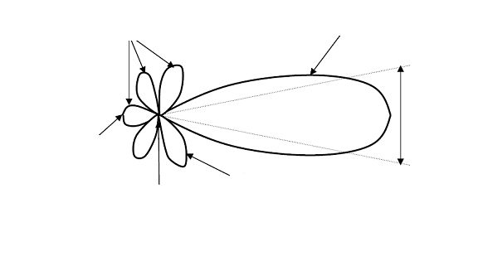
Minor Lobes
Back Lobe
Null
Side Lobe
Main Lobe
HPBW
Figure 1.5 Radiation Pattern of a Directional Antenna [3].

Figure 1.5, the half power beam width (HPBW) can be defined as the angle subtended by the half power points of the main lobe, main lobe is the radiation lobe containing the direction of maximum radiation, and minor lobe is all the lobes other than the main lobe. These lobes represent the radiation in undesired directions. The level of minor lobes is usually expressed as a ratio of the power density in the lobe in question to that of the major lobe.
This ratio is called as the side lobe level (expressed in decibels). Back lobe is the minor lobe diametrically opposite the main lobe; side lobes are the minor lobes adjacent to the main lobe and are separated by various nulls. Side lobes are generally the largest among the minor lobes. In most wireless systems, minor lobes are undesired. Hence a good antenna design should minimize the minor lobes [3].
1.5.2 Polarization

Polarization of a radiated wave is defined as the property of an electromagnetic wave describing the time varying direction and relative magnitude of the electric field vector [3]. The polarization of an antenna refers to the polarization of the electric field vector of the radiated wave. In other words, the position and direction of the electric field with reference to the earth’s surface or ground determines the wave polarization.
The most common types of polarization include the linear (horizontal or vertical) and circular (right hand polarization or the left hand polarization). If the path of the electric field vector is back and forth along a line, it is said to be linearly polarized. Figure 1.6 shows a linearly polarized wave. In a circularly polarized wave, the electric field vector remains constant in length but rotates around in a circular path.
A left hand circular polarized wave is one in which the wave rotates counterclockwise whereas right hand circular polarized wave exhibits clockwise motion as shown in Figure 1.7.

Figure 1.6 Linearly (Vertically) Polarized Wave [3].

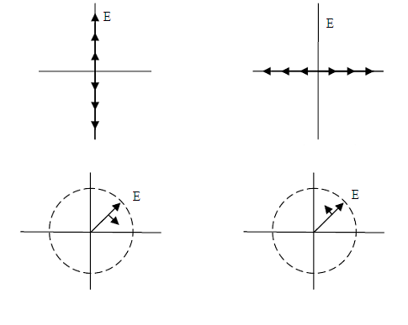
Vertical Linear Polarization
Horizontal Linear Polarization
Right Hand Circular Polarization
Left Hand Circular Polarization

Figure 1.7 Commonly Used Polarization Schemes [3].

1.6 Directivity

The directivity of an antenna is defined as the ratio of the radiation intensity in a given direction from the antenna to the radiation intensity averaged over all directions [4]. In other words, the directivity $(D)$ of a nonisotropic source is equal to the ratio of its radiation intensity in a given direction, to an isotropic source:
$D=\frac{U}{U_{i}}=\frac{4πU}{P}$, (1.6)

where U is the radiation intensity of the antenna, $U_{i}$ is the radiation intensity of an isotropic source and $P$ is the total power radiated. The maximum directivity $(D_{\text{max}})$ is defined by [3]:

$D_{\text{max}}=\frac{U_{\text{max}}}{U_{i}}=\frac{4πU_{\text{max}}}{P}$, (1.7)
where $U_{\text{max}}$ is the maximum radiation intensity and $P$ is the total radiated power. Directivity is a dimensionless quantity, since it is the ratio of two radiation intensities. Hence, it is generally expressed in $\text{dB}$.
The directivity of an antenna can be easily estimated from the radiation pattern of the antenna. An antenna that has a narrow main lobe would have better directivity, than the one which has a broad main lobe, hence it is called more directive [3].

1.7Antenna Efficiency

The antenna efficiency is a parameter which takes into account the amount of losses at the terminals of the antenna within the structure of the antenna. The types of losses are given as follows:
• Reflections because of mismatch between the transmitter and the antenna.
• $I^{2}R$ losses (conduction and dielectric) .
The total antenna efficiency can be written as
$e_{t}=e_{r}e_{c}e_{d}$, (1.8)
$e_{r}=1−\left|Γ^{2}\right|$, (1.9)
where $e_{r}$ is reflection (mismatch) efficiency, $e_{c}$ is conduction efficiency and $e_{d}$ is dielectric efficiency. Since $e_{c}$ and $e_{d}$ are difficult to separate, they are lumped together to form the antenna radiation efficiency $e_{\text{cd}}$ which is given by
$e_{\text{cd}}=e_{c}e_{d}=\frac{R_{r}}{R_{L}}$ , (1.10)
which is simply defined as the ratio of the power delivered to the radiation resistance $(R_{r})$to the power delivered to $(R_{L})$ [3].

1.8 Antenna Gain

Antenna gain is a parameter which is closely related to the directivity of the antenna. The directivity is how much an antenna concentrates energy in one direction in preference to radiation in other directions. Hence, if the antenna is 100% efficient, then the directivity would be equal to the antenna gain and the antenna would be an isotropic radiator.
Since all antennas will radiate more in some direction that in others, therefore the gain is the amount of power that can be achieved in one direction at the expense of the power lost in the others [5]. The gain is always related to the main lobe and is specified in the direction of maximum radiation. Antenna gain can be calculated by using the following expression:

$G\left(θ,φ\right)=$ $e_{\text{cd}}D\left(θ,φ\right)$ (1.11)
or
$G=\frac{4π}{BW_{φ}BW_{θ}}$ (1.12)

where ${(\text{BW}}_{φ})$ is the azimuth beam width and ${(\text{BW}}_{θ})$ is the elevation beam width. The bandwidth of an antenna, is the range of usable frequencies within which the performance of the antenna, with respect to some characteristic, conforms to a specified standard.
The bandwidth can be the range of frequencies on either side of the center frequency where the antenna characteristics like input impedance, radiation pattern, beamwidth, polarization, side lobe level or gain, are close to those values which have been obtained at the center frequency.
The bandwidth of a broadband antenna can be defined as the ratio of the upper to lower frequencies of acceptable operation. The bandwidth of a narrowband antenna can be defined as the percentage of the frequency difference over the center frequency [3].

1.9 Front-to-Back Ratio

It is often useful to compare the front-to-back ratio of directional antennas. This is the ratio of the maximum directivity of an antenna to its directivity in the opposite direction. For example, when the radiation pattern is plotted on a relative dB scale, the front-to-back ratio is the difference in dB between the level of the maximum radiation in the forward direction and the level of radiation at${\text{180}}^{°}$. This number is meaningless for an omnidirectional antenna, but it gives one an idea of the amount of power directed forward on a very directional antenna. Front to back can be described by $F/B$ [6].

1.10 Input Impedance

The input impedance of an antenna is defined, as the impedance presented by an antenna at its terminals or the ratio of the voltage to the current at the pair of terminals or the ratio of the appropriate components of the electric to magnetic fields at a point [3]. Hence, the impedance $(Z_{\text{in}})$ at the teminals of antenna is defined by:
$Z_{\text{in}}=R_{\text{in}}+jX_{\text{in}}$ , (1.13)
where $R_{\text{in}}$ is the antenna resistance and $X_{\text{in}}$ is the antenna reactance. Futher, the imaginary part $(X_{\text{in}})$, represents the power stored in the near field of the antenna. Reactance is the imaginary part of electrical impedance, a measure of opposition to a sinusoidal alternating current. Reactance arises from the presence of inductance and capacitance within a circuit [7].
The resistive part $R_{\text{in}}$, consists of two components, the radiation resistance $R_{r}$ and the loss resistance $R_{L}$. The power associated with the radiation resistance is the power actually radiated by the antenna, while the power dissipated in the loss resistance is lost as heat in the antenna itself due to dielectric or conducting losses [3].

1.11 Summary

This chapter discussed the definitions and related terminologies regarding antenna, which are very useful for future studies. The antenna parameters which are associated with the radiation pattern, the radiation efficiency, the input impedance, and bandwidth have been discussed. Furthermore, the gain, beam width, polarization, minor lobe level and radiation efficiency have also been defined.

